Experiment-12
AIM: Simulate Hit or Miss Transformation on images.

Theory:
The Hit or Miss transformation is a morphological operation used to detect specific patterns or shapes in an image. It is commonly used for shape recognition or pattern matching.

The operation requires two structuring elements: one for foreground (hits) and another for background (misses). The foreground structuring element represents the desired pattern to be matched, while the background structuring element represents the complement of the pattern.

During the transformation, the foreground structuring element is matched against the foreground pixels in the image, and the background structuring element is matched against the background pixels. Only those pixels that match both structuring elements are considered hits.

Image used: A binary image (hitmiss_input.png, 300 x 300 pixels) having thin white lines on a black background. It contains 3 horizontal and 3 vertical lines which cross each other at 9 points, and also a circle and a diagonal line which do not have the plus shape. The pattern used is a plus shape (+), so the 9 crossing points should be detected and the circle and the diagonal line should not be detected. Hit or Miss needs a binary image and a pattern of the size of a few pixels, so a thin line image is more suitable than a photograph.

Program
import cv2
import numpy as np
import matplotlib.pyplot as plt

# Load the binary image
image = cv2.imread('hitmiss_input.png', 0) # Replace with your image path

# Define the structuring element for the pattern to be detected (0 for don't care, 1 for foreground, -1 for background)
pattern = np.array([[-1, 1, -1],
[1, 1, 1],
[-1, 1, -1]], dtype=np.int8)

# Apply the Hit or Miss Transformation
result = cv2.morphologyEx(image, cv2.MORPH_HITMISS, pattern)

# Positions of the pixels where the pattern is found
hits = np.argwhere(result > 0)
print("Number of hits :", len(hits))
print("Positions (row, column):")
print(hits)

# Enlarge the single pixel hits so that they are visible in the display
result_display = cv2.dilate(result, np.ones((7, 7), np.uint8))

# Display the original image and the result
plt.figure(figsize=(10, 5))

plt.subplot(1, 2, 1)
plt.imshow(image, cmap='gray')
plt.title('Original Image')
plt.axis('off')

plt.subplot(1, 2, 2)
plt.imshow(result_display, cmap='gray')
plt.title('Hit or Miss Result')
plt.axis('off')

plt.tight_layout()
plt.show()

Output:-
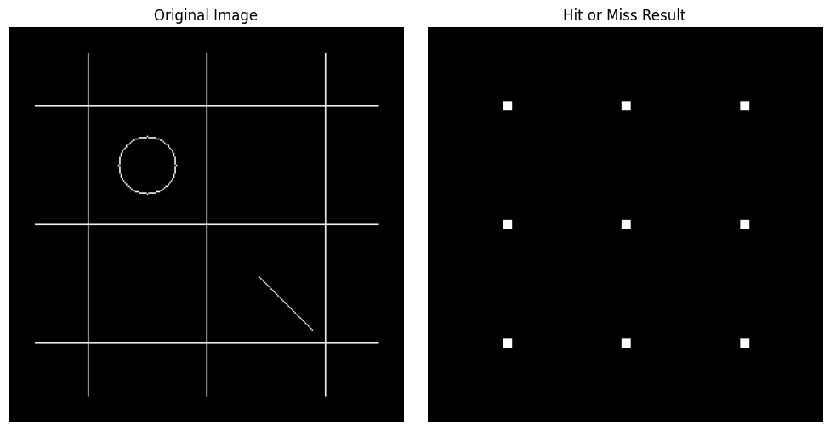

Number of hits : 9
Positions (row, column):
[[ 60 60]
[ 60 150]
[ 60 240]
[150 60]
[150 150]
[150 240]
[240 60]
[240 150]
[240 240]]

Observations:-
The structuring element has the foreground pixels (1) in the centre and in the four neighbours (up, down, left, right) and the background pixels (-1) in the four corners. A pixel is a hit only when the foreground part and the background part both match at the same time.
The transformation found 9 hits, at the 9 points where a horizontal line crosses a vertical line, which are (60, 60), (60, 150), (60, 240), (150, 60), (150, 150), (150, 240), (240, 60), (240, 150) and (240, 240).
The circle and the diagonal line were not detected, because their pixels do not have the plus shape. The ends of the lines are also not detected, because a pixel at the end of a line does not have all four neighbours as foreground.
Each hit is a single pixel. In the result image the hits are enlarged only for display, so that they are visible.

Conclusion
The Hit or Miss transformation detects the exact shape given by the structuring element in a binary image. The foreground element must match the object pixels and the background element must match the surrounding pixels, so only the pixels with the required pattern (here the plus shape at the line crossings) are marked, and all other shapes are ignored.

